**DL – Lab 09 – IT21250156**

**Part 01**

**Part 02**

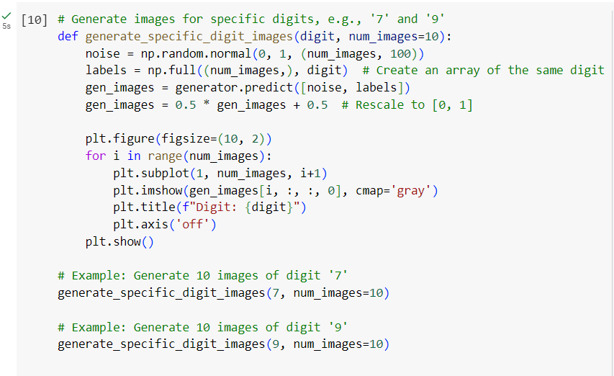

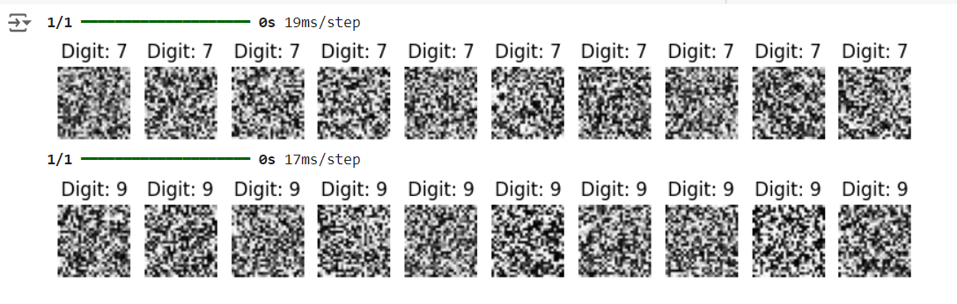

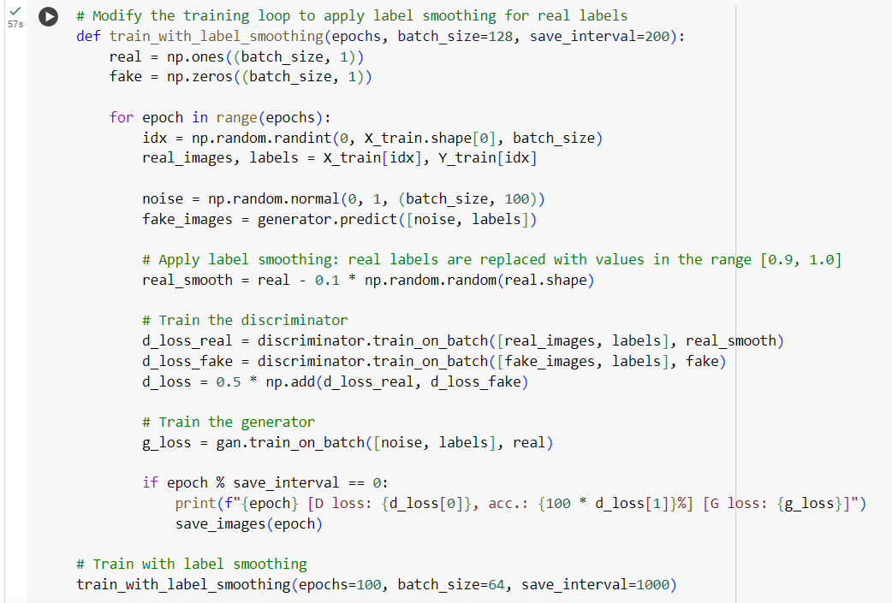

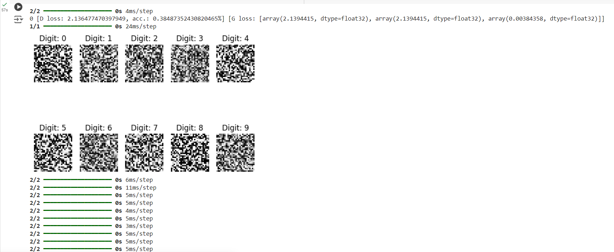

1. 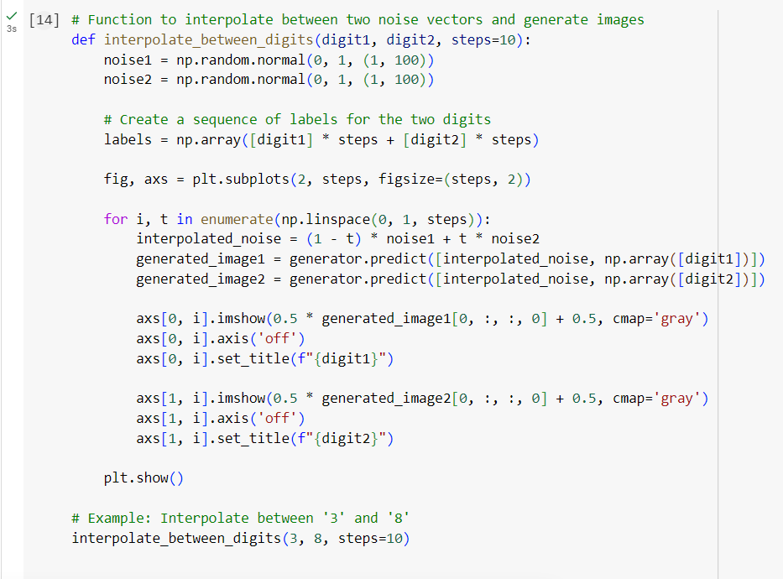

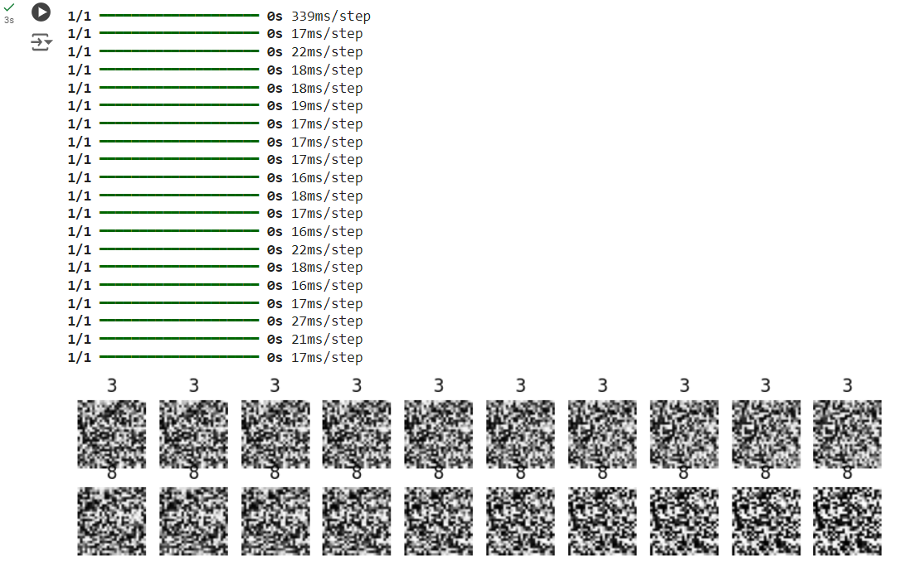

**Part 03**

1. 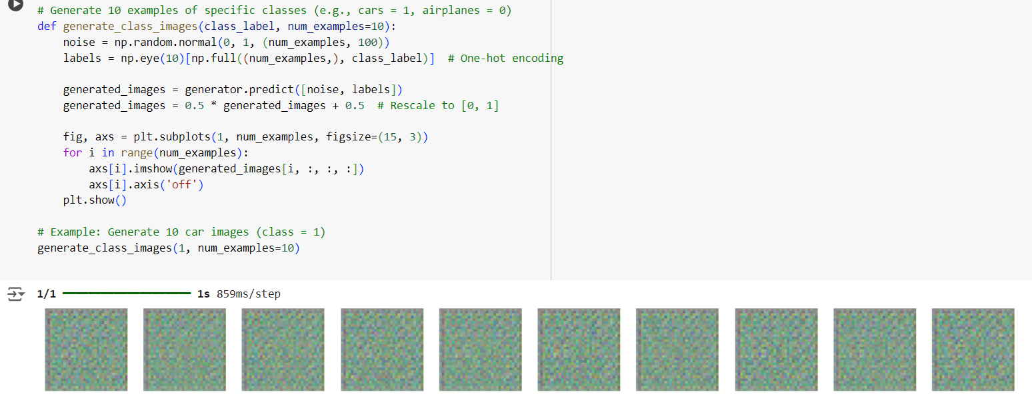
2. 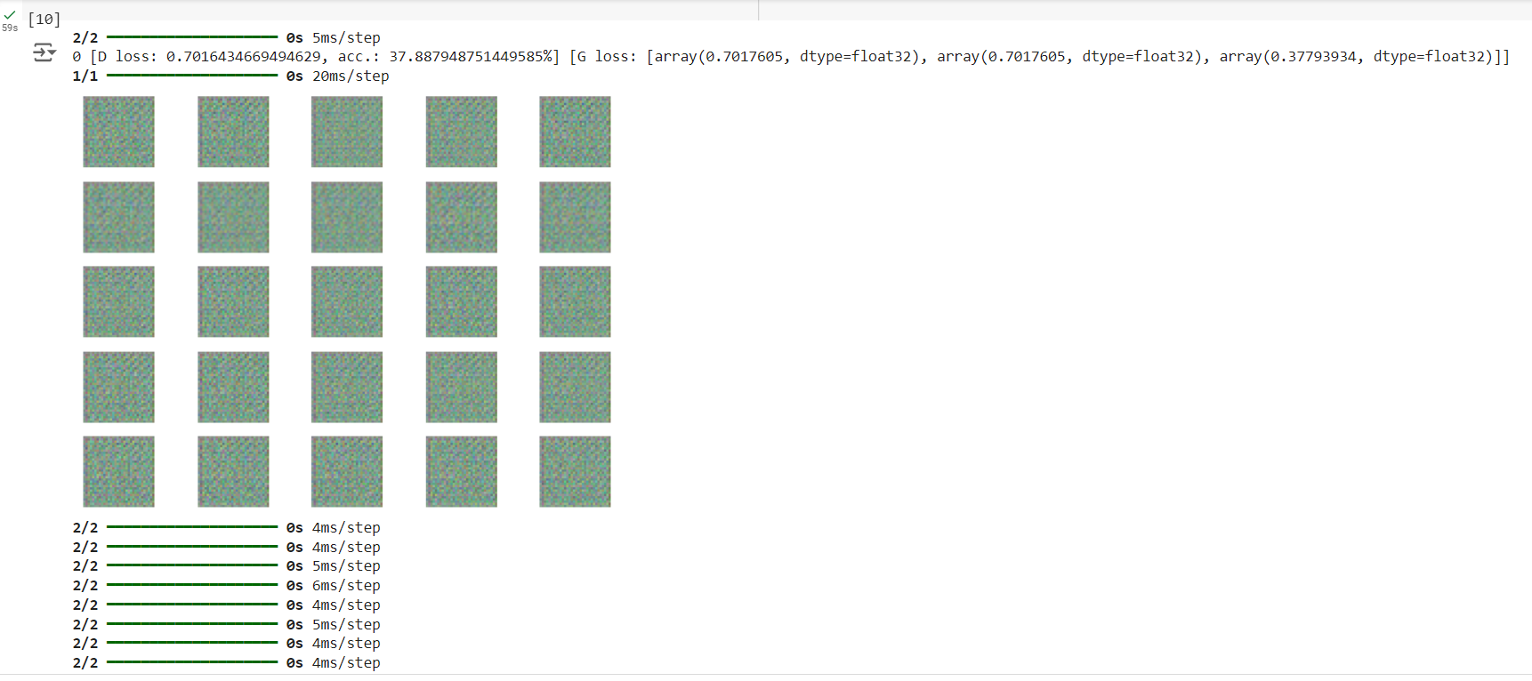

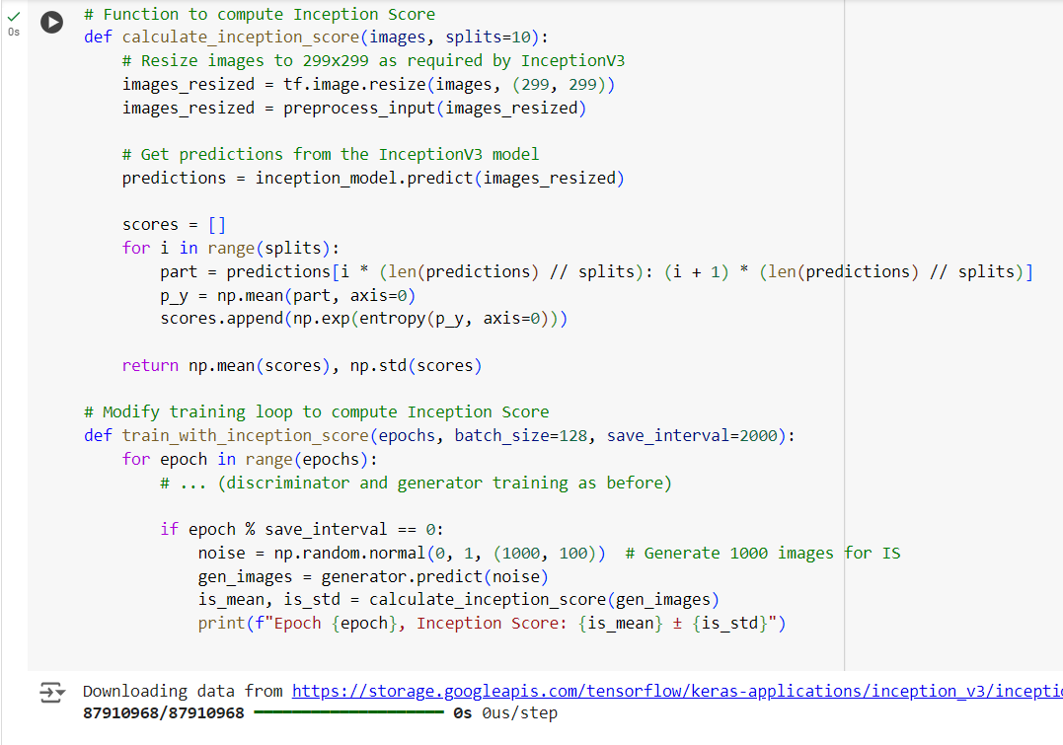

1. 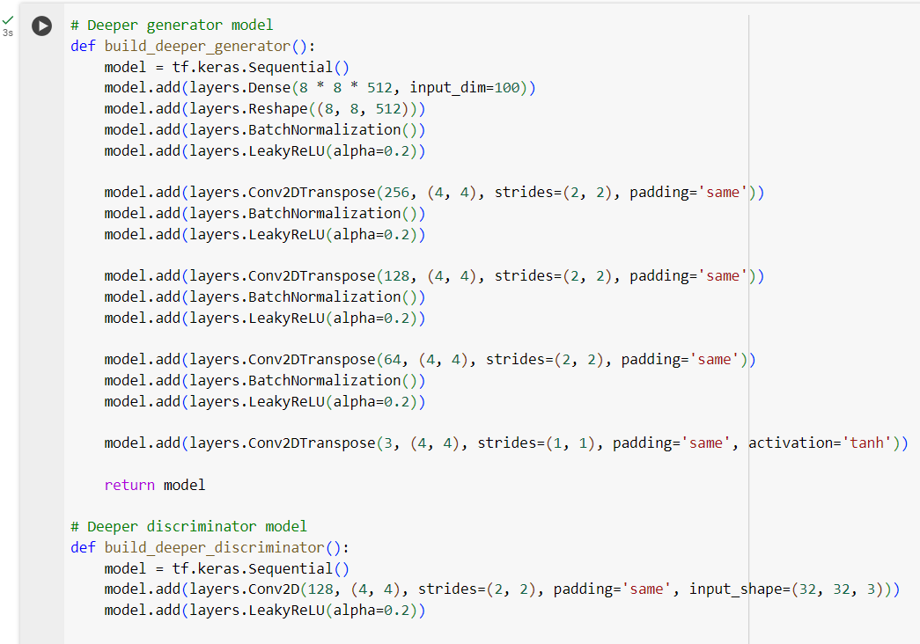

**Submission**

**b. Effects of Parameter Adjustments**

* **Latent Space Dimensions:** Increasing the latent space dimension (e.g., from 100 to 200) enables the model to learn more intricate features, which can enhance the diversity and detail of generated images. However, if the latent space becomes too large, training may become more challenging, potentially resulting in noisy or less coherent outputs.
* **Optimizers:** Using optimizers like Adam with varying learning rates (e.g., 0.0002) influences the stability of training. A lower learning rate generally offers more stable progress with gradual improvements, while a higher learning rate can accelerate convergence but may also introduce instability in the model.
* **Batch Size:** Smaller batch sizes (e.g., 32) may cause noisier gradients and less stable training but could help the model capture a wider range of features. On the other hand, larger batch sizes (e.g., 128) tend to smooth out the learning process, although they may lead to overfitting or require more computational resources.

**c. Image Quality and Variability**

* **Quality:** As training progresses, the generated images typically become sharper and more realistic, particularly when the GAN is finely tuned. In the early stages, images may appear blurry, but with further training, they improve in clarity. However, if the model is too complex or training is unstable, it may suffer from mode collapse, where the generator consistently produces nearly identical images.
* **Range:** The variety of generated images depends on how diverse the latent space is. When parameters are tuned effectively, the model can generate a wide array of objects and styles within the same class. However, a smaller latent space or poorly optimized parameters may result in repetitive outputs, where the images lack sufficient diversity.